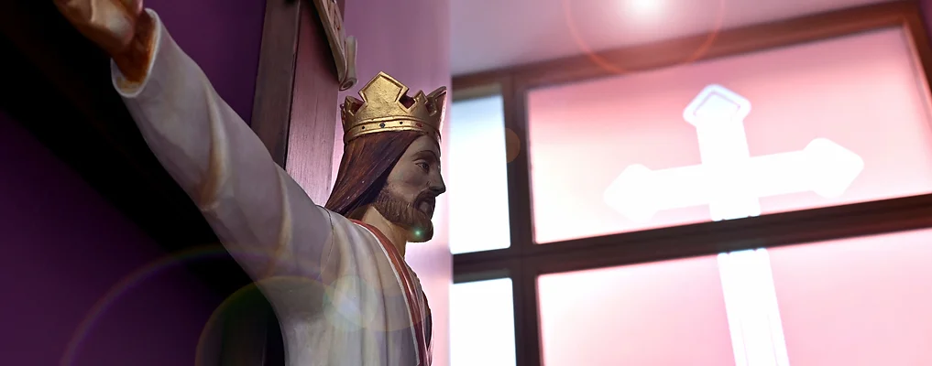
Chaplaincy: Today and the future.
‘Inspiring hearts and minds with Christ at the Centre of all we say and do.’

The past:
At BMCC, our chaplaincy team helped us to create an All-Saints Day mass for the whole school, some of the students in the chaplaincy team read out Bidding Prayers and the choir sang songs. Father Paul came in and led the mass and the communion.
In the Chaplaincy team we raise money for different charities, we make events, like mass, happen and have fun doing so. Last year, we raised money for Breast Cancer Awareness by doing inter-house competitions like football, bench ball and general knowledge quizzes. The players had to pay 15p each to play along with the people watching them play. The students in the team have also led different acts of prayer and liturgy (assembly) and have gone to different form groups by reading out different pieces of paper they wrote about black history month.
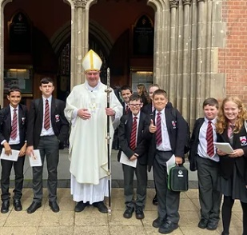
This year we have gone to Saint Chad’s Cathedral to go and participate in a mass by Bishop Steven. Afterwards, we were able to have tea, coffee and cakes with the different chaplaincy teams from around the West midlands.

This term:
Present:
Now we have been having meetings to discuss further plans for the school and we have been giving around different things for the prayer tables like the purple cloth to lay down for the birth of Christ, Hail Mary statues and different booklets about prayer. We have given our breaktimes and lunchtimes and helped Mr. Baker and our Lay chaplain, Miss Collins, so that the teachers and students can have fun days like festivals for things like black history month.
Also, around Christmastime, we gave over 500 items of food to the foodbank so that disadvantaged people can have a nice meal for Christmas. We have helped out in creating online masses with Father Paul. In December, the advent part of the liturgical calendar. This means the prayer tables will be purple and we will having a Christmas service to celebrate Jesus’ birth. We will be having more inter-house activities before we break up for the Christmas holidays.

Future:
As we near the Epiphany, the chaplaincy team are creating a special online mass to celebrate 12 days after Jesus’ birth and Jesus’ baptism with John the Baptist on the 6th of Jan. The epiphany commemorates how a star led the Magi, the three kings, to the Baby Jesus. As Pope Francis once said “We are called to journey towards Jesus, for He is the North star that lights up the sky of life and guides our steps towards true joy.”
Most countries celebrate this with parades and decorative floats. In February, Shrove Tuesday (Known as Mardi Gras) it is the feast day before the start of Lent and Ash Wednesday, with it at school we have palm ash placed on everyone’s hands in the sign of the cross. On the 9th of April we celebrate Easter Sunday where we held a mass for the sacrifice and the resurrection of Jesus Christ.

Our College Prayer
Dear God,
On our journey to be who you call us to be:
Give us the strength and resilience, shown by St Peter, to never give up.
Help us to inspire others along the way by keeping your son, Jesus Christ, at the centre of all that we say and do.
Amen
​
Bishop Milner: Pray for us
St Peter: Pray for us

Created by M Whittaker, L-M Jones and K Slater.

